

Highlights:

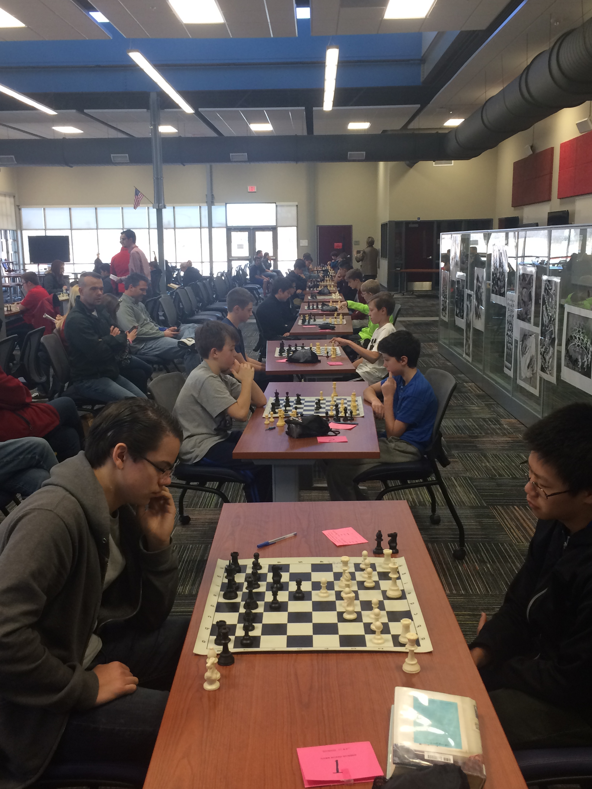

NWA Winter Chess Tournament @ SOI

The 2016-2017 school year is zooming by. In the rear view mirror is the successful conclusion of these winter events: 2017 AGATE Conference, all NWA GT Program Applications being approved, 2 NWA Quiz Bowl Tournaments, ACE Finals, and the NWA Winter Chess Tournament.

When thinking ahead for the spring quarter related to Gifted Education are these activities : 2 NWA Science Olympiad Tournaments, the NWA Chess Tournament of Champions, districts administrating academic testing (ACT Aspire & AP), and the NWAESC providing quality Professional Development workshop opportunities for the teachers.

Dustin Seaton will be the new NWAESC GT Specialist starting July 1, 2017

Calendar

**Apr 5** ESC GT Specialist meeting @ Crystal Bridges Museum in Bentonville

**Apr 9**  AGQBA Sr. High State Tournament

**Apr 17 & 18** NWA Science Olympiad Tournaments

**Apr 23** AGQBA State Finals @ AETN Conway

**Apr. 29** NWA Chess Tournament of Champions

**May 4** – NWAESC Board Meeting – ACE & AGATE encouragement to participate presentation

**May 15** – NWA GT Administrators meeting @ the AMAZEUM in Bentonville

**May 17 & 18** ESC GT Specialist 2 day workshop @ Wyndham Riverfront LR

**May 24 – 27** OM World Finals, Lancing MI

**May 31** **– June 2** GT Curriculum Writing 3 day workshop

**June 26 & 27** Pre-AP Math Training

**June 27 – 29** Grasping Phenomenal Science (GPS) Training

**July 31 & Aug. 1** Pre-APEnglish & Social Sciences Training

Larry Driver, Gifted Education Specialist for Northwest Arkansas Service Cooperative

4 N. Double Springs Rd. Farmington AR 72730

479-267-7450 ldriver@starfishnw..org

Northwest Arkansas Education Service

Cooperative

April - June 2017

*Advocating Opportunities for Gifted and Talented Students to grow and shine,*

**ARKANSAS GEMS**